Fall into Spring
Educational Garden Conference
18th Annual
​Master Gardener Association Genesee County Michigan presents
Saturday, October 7, 2023
8:00 A.M. - 3:00 P.M.
Mott Community College Event Center​
1401 E. Court Street, Flint, MI 48503
Barslund Judd
"Climate Change Requires Smart Gardening"

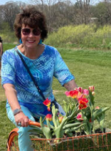
Sandra Wilkins
"Painting a Garden Symphony"

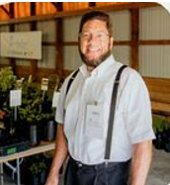
Vincent Ste. Marie
"Through The Year in Blooms"

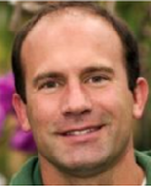
George Papadelis
"What’s New and Fabulous for 2024"

Conference fee Includes
Continental breakfast - bagels, muffins, fruit,
yogurt, coffee and tea
Lunch - Roly Poly wraps (Gluten free and vegetarian available), fresh fruit, vegetable tray, chips
Dessert
Door prizes
Vendors
Demonstrations and Activities- Beaded plant stakes, Botanical Prints, Making fabric gnomes, Tool sharpening and care of tools
Bring tools to be sharpened
Andrew Thomas, Strap and Stone,
Tool sharpening and care of tools
• Knives - $1 per inch
• Garden tools - sm. $5/lg. $7
• Scissors - $5
$60 Conference fee deadline 9-23-23
4 MG educational hours
Check website to pay online
or for more information
https://fallintospring.weebly.com/
Make checks payable to: MGAGCM
Mail registration to:
MGAGCM
Fall Into Spring Conference
P.O. Box 94 Flushing, MI 48433
Include
Name______________________________
Phone_____________________________
Email______________________________
Questions? Call or email Marie Luck-Allard at 810-919-7909 OR mariekallard@gmail.com

